Take a Break from Travel to Unravel
Explore the World of Comfort in (Insert City).

Touring Package Includes:
- Complimentary Parking
- Free Wi-Fi
- On-site Laundry Facilities
- Complimentary Breakfast
- $xx.xx+ Tax Per Day
- Based on Availability

Insert Hotel Name Address
Phone Number

Insert hotel website

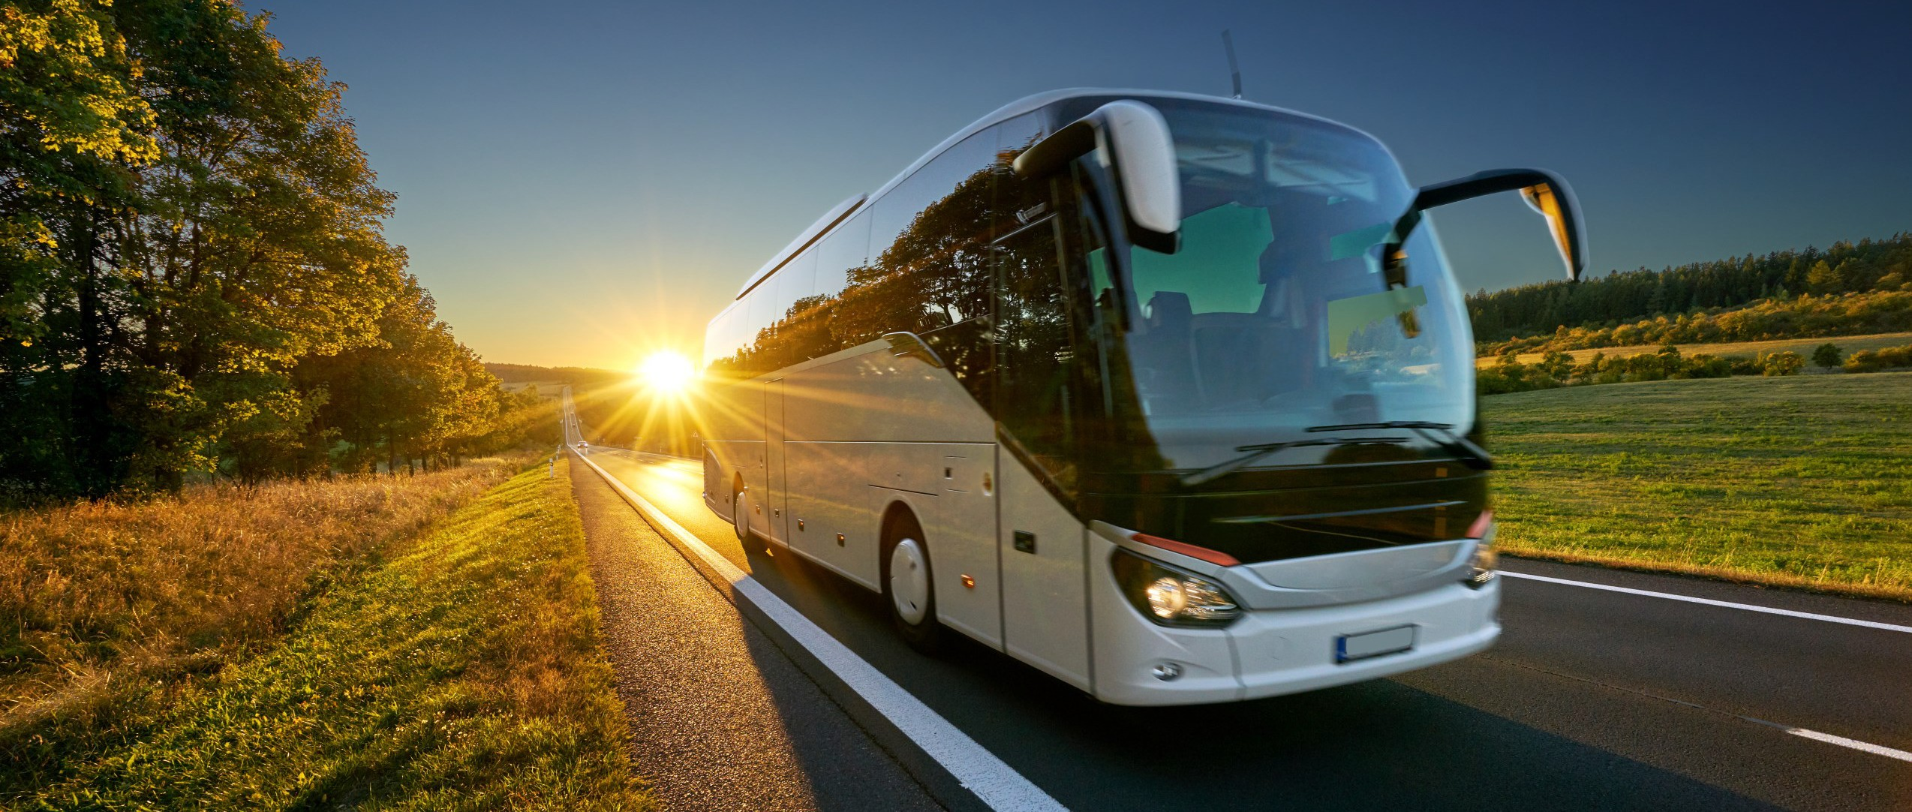

Insert Name | Title | ###-###-#### | email address
© 2023 Jacaruso Enterprises, Inc.

